Steps to create jenkin job for pfs-branch.

Click on New Item in Proview link of Jenkins

<http://ec2-34-205-148-215.compute-1.amazonaws.com:8080/job/Proview/>

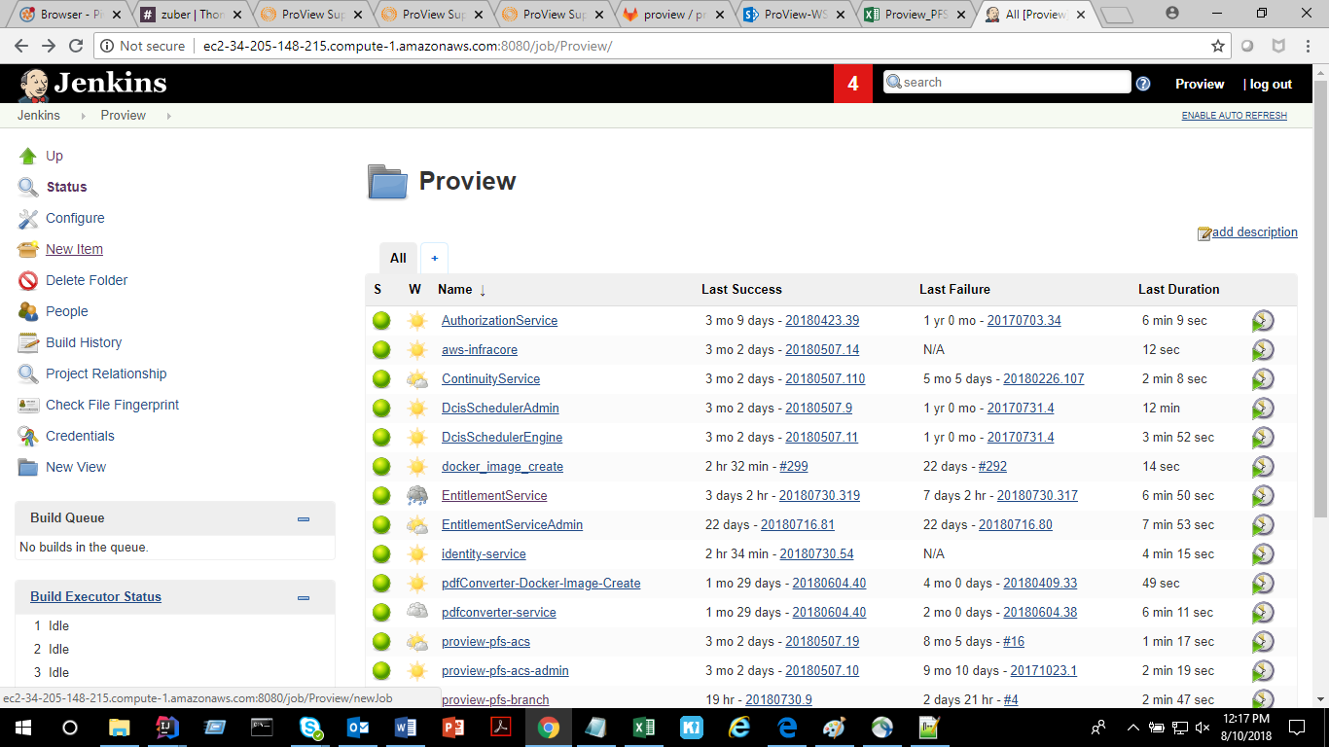

Enter an Item Name as provie-pfs-branch (for any other new item give the name accordingly)

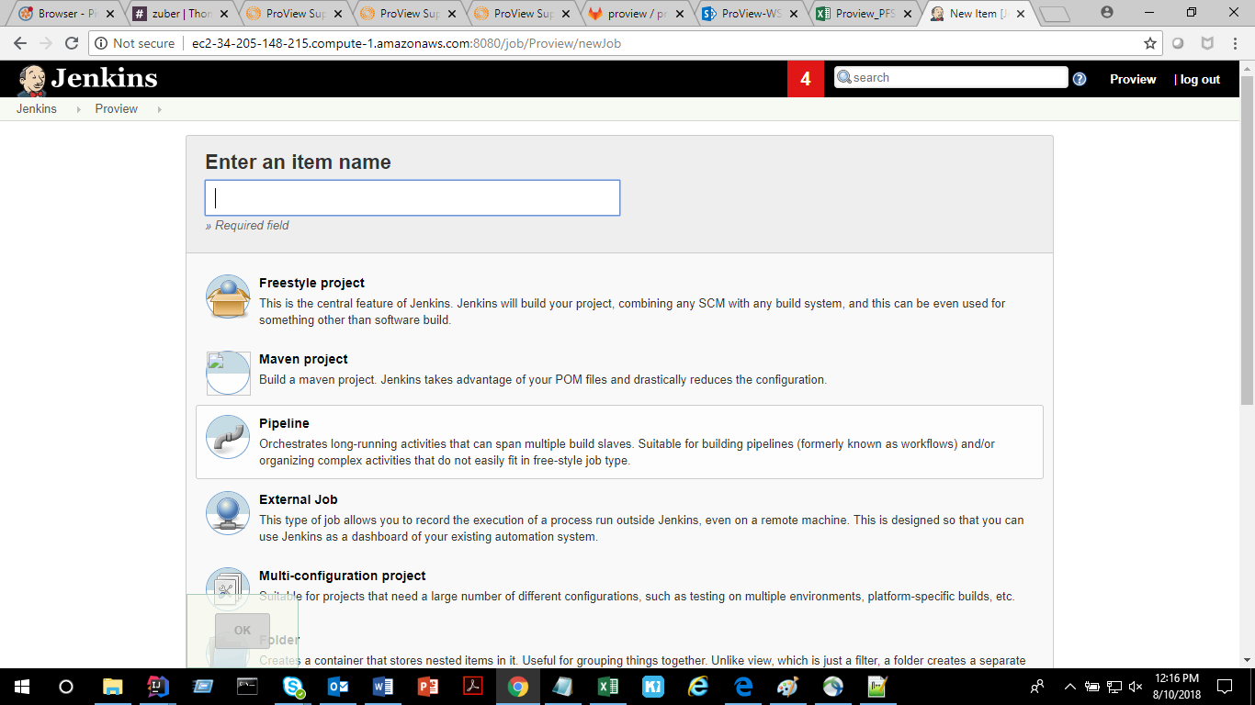

Copy from give proview-pfs-site (for referring which job the new job should be created)

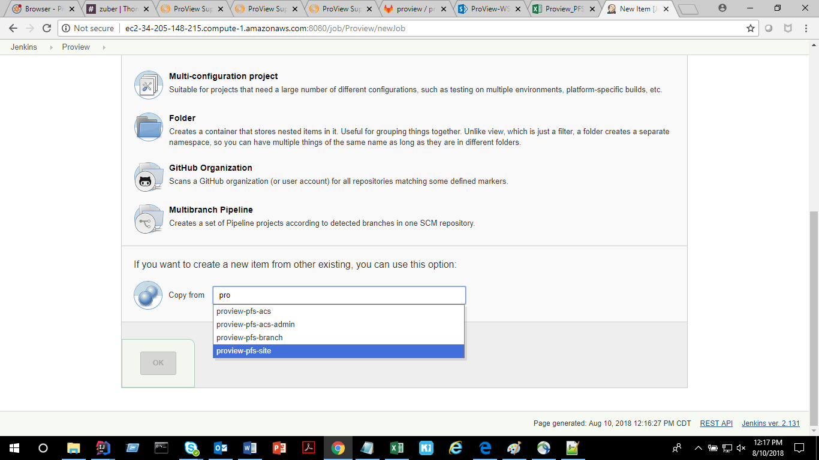

Now the link <http://ec2-34-205-148-215.compute-1.amazonaws.com:8080/job/Proview/job/proview-pfs-branch/> will be available and click of configure

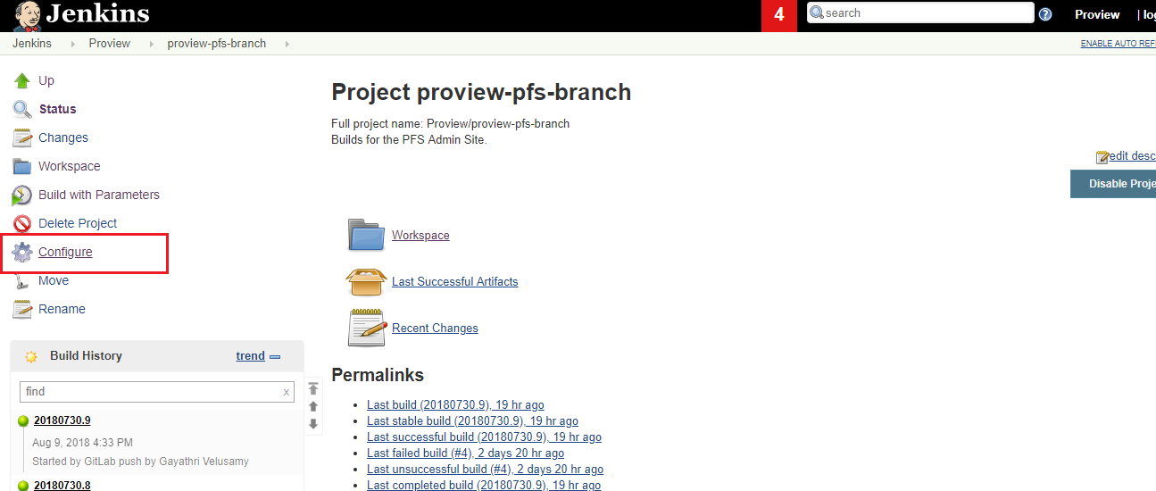

In Build-Conditional Step

#!/bin/bash

set -ex

cd $WORKSPACE/server/nginx

sed -i 's/proview-pfs-site/proview-pfs-branch/g' nginx.conf

cd $WORKSPACE/server

sed -i 's/site-app/branch-app/g' docker-compose.yaml

sed -i "s/^\([ \t]\*image\:[ ]\*.\*branch-app$\)/\1:$VERSION/" docker-compose.yaml

docker-compose build

docker-compose push

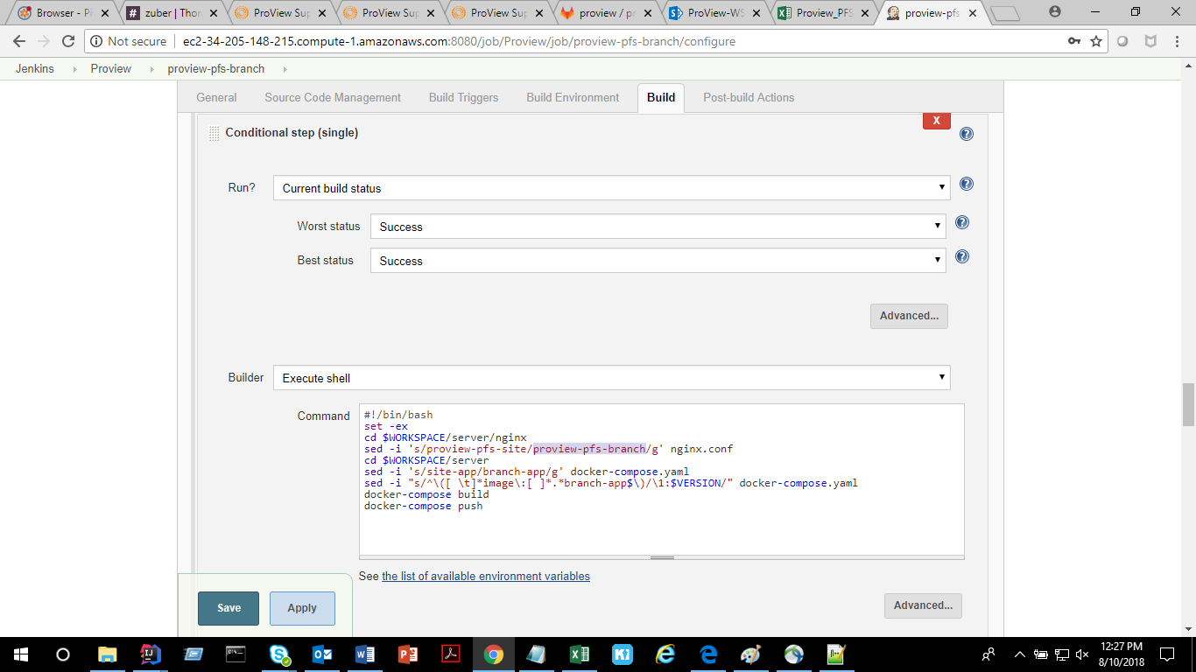

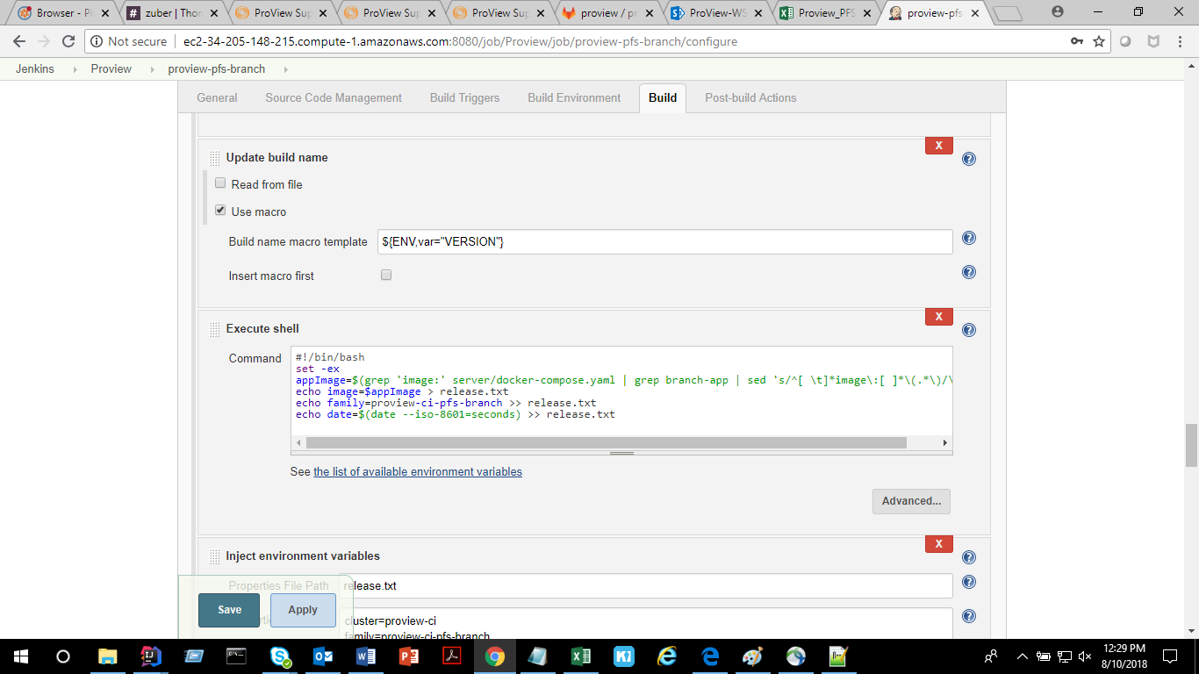

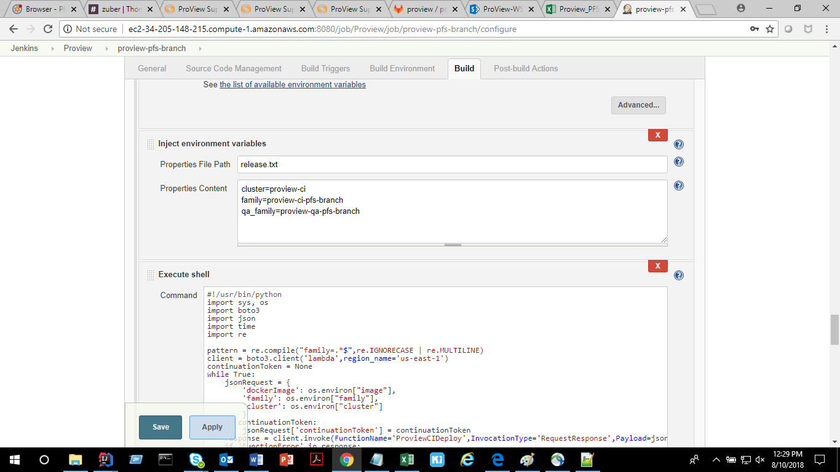

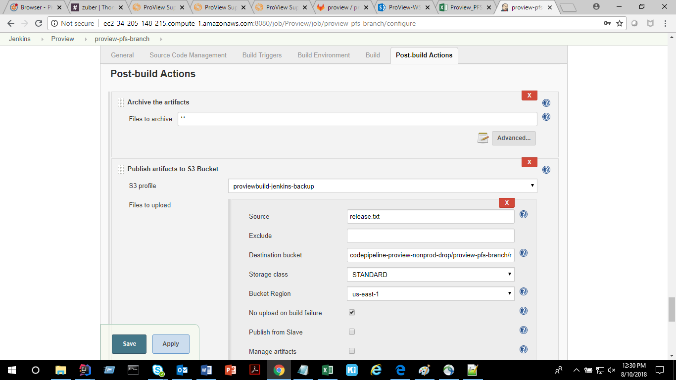

Destination bucket as

codepipeline-proview-nonprod-drop/proview-pfs-branch/release

Click save and apply.

Add URL and secret token for the job and then add webhooks.

<https://git.sami.int.thomsonreuters.com/proview/proview-pfs-site/settings/integrations>

Next to the secret token input, you need to update the “Filter branches by name”

(Under “Advanced”)

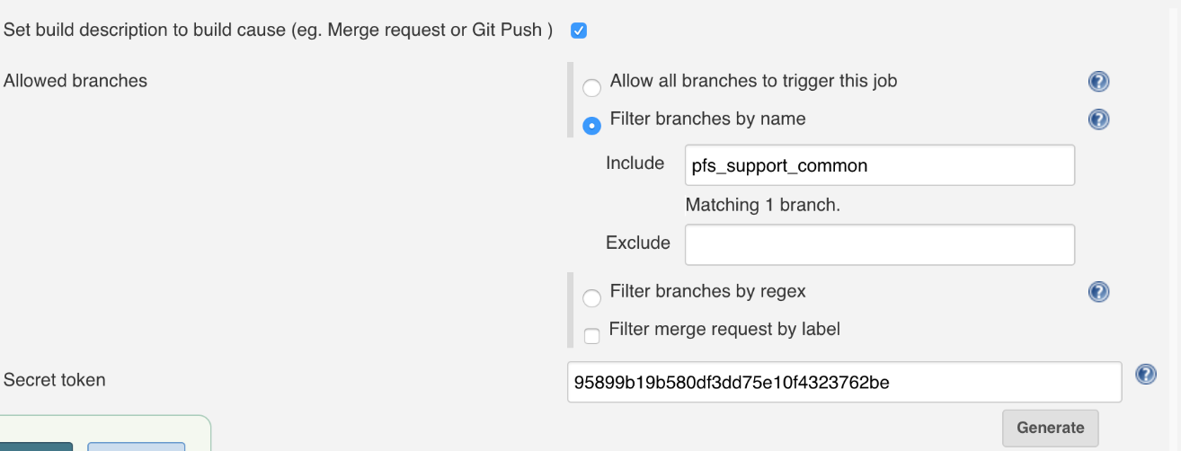

Now the Jenkin Job will be auto triggered for the desired branch.